A PROJECT REPORT ON

SMART PARKING SYSTEM

FOR

**Intel® Intelligent Systems Lab**

BY:

MD. MAZHER

MUSKAN PANDEY

IN PARTIAL FULFILMENT OF

TRAINING PROGRAMME ON INTERNET OF THING

SHRI SHANKRACHARYA INSTITUTE OF PROFESSIONAL MANAGEMENT AND TECHNOLOGY

RAIPUR (CHHATTISGARH)

DECLARATION

I hereby declare that the Project report entitled " SMART PARKING SYSTEM" submitted to the **Intel® Intelligent System** in partial fulfilment of the requirements for the award of the “TRAINING PROGRAMME ON INTERNET OF THINGS” is a record of original dissertation work done by me, under the guidance and supervision of MR.ROHIT RAJ SINGH,MR. SUMIT ROY Assistant Professor, Department of Electronics and Telecommunication Engineering, Shri Shankracharya Institute of Professional Management and Technology, Raipur and it has not formed the basis for the award of any Degree/Diploma/Associateship/ Fellowship or other similar title to any candidate of any University.

PLACE:

DATE:

ACKNOWLEDGEMENT

I have taken efforts in this project. However, it would not have been possible without the kind support and help of many individuals and organizations. I would like to extend my sincere thanks to all of them.

I am highly indebted to Mr. Rohit Raj Singh and Mr. Sumit Roy for their guidance and constant supervision as well as for providing necessary information regarding the project & also for their support in completing the project.

I would like to express my gratitude towards members of FICE Education Pvt. Ltd. for their kind co-operation and encouragement which help me in completion of this project.

I would like to express my special gratitude and thanks to industry persons for giving me such attention and time.

CONTENTS:-

1. INTRODUCTION
2. PROBLEM IDENTIFICATION
3. PROPOSED SOLUTION
4. HARDWARE AND SOFTWARE REQUIRED
5. BLOCK DIAGRAM
6. PROJECT DESCRIPTION AND WORKING
7. FUTURE SCOPE
8. CONCLUSION AND REFERENCE

**INTRODUCTION**

**Problem Statement**

So Hard to find a parking spot!

**Background Summary**

Traffic congestion caused by vehicle is an alarming problem at a global scale and it has been growing exponentially. Car parking problem is a major contributor and has been, still a major problem with increasing vehicle size in the luxurious segment and confined parking spaces in urban cities. Searching for a parking space is a routine (and often frustrating) activity for many people in cities around the world. This search burns about one million barrels of the world’s oil every day. As the global population continues to urbanize, without a well-planned, convenience-driven retreat from the car these problems will worsen.

According to a report, Smart Parking could result in 2,20,000 gallons of fuels saving till 2030 and approx. 3,00,000 gallons of fuels saved by 2050 , if implemented successfully .

**PROBLEM IDENTIFICATION**

India is facing a new problem nowadays – lack of sufficient parking space. With families getting smaller and the total number of motor vehicles exceeding the total number of heads per family, the parking scenario is woefully falling short of the current requirements in the country. The situation is such that on any given working day approximately 40% of the roads in urban India are taken up for just parking the cars. The problem has been further exacerbated by the fact that nowadays even people from low income group are able to own cars. The number of families with cars has become much more than what the country is able to manage.

**PROPOSED SOLUTION**

The cities in India are highly congested and also it been difficult to find parking spot. Suppose if we have smart system that told us in advance about vacant spot, Sound cool it will save fuel, money, limit co2 emission and most important things is that it save TIME. So, in the same way our project work.

There will a parking spot in some selected area with sensor, this sensor connected with main controller board and then with google firebase system for user authentication and data purpose.

User have user application access by just simply signing it (user name, email id , phone number and password). After signup, login screen appear. once user have access, a map will be opened show his/her current location. suppose if a person wants to go place A, so he/she mark that place on map. App will show all the parking place nearby place A and along with vacant spot. You just need to pay reasonable amount and that spot will be book for you for next couple of minutes. If you want extend your parking time you can extend, by just paying some extra amount. You can go anywhere like shopping, restaurants, work place etc. without bothering about your car. This parking area is equipped with AI Camera so that it can provide security to you and your car.

Finding your car on parking slot now become so easier with the help of app, it will show your car spot(live). What if you run out of money, don’t bother. Your parking account is linked with your bank account. You can pay it with some third party payment app such paytm, google pay, paypal, etc according to your convenient.

**HARDWARE AND SOFTWARE REQUIRED**

HARDWARE -

1.RASPBERRY PI 4

2.IR SENSORS

SOFTWARE -

1.GOOGLE FIREBASE PLATFORM

2.KODULAR- ANDROID APP DEVELOPMENT

**BLOCK DIAGRAM**

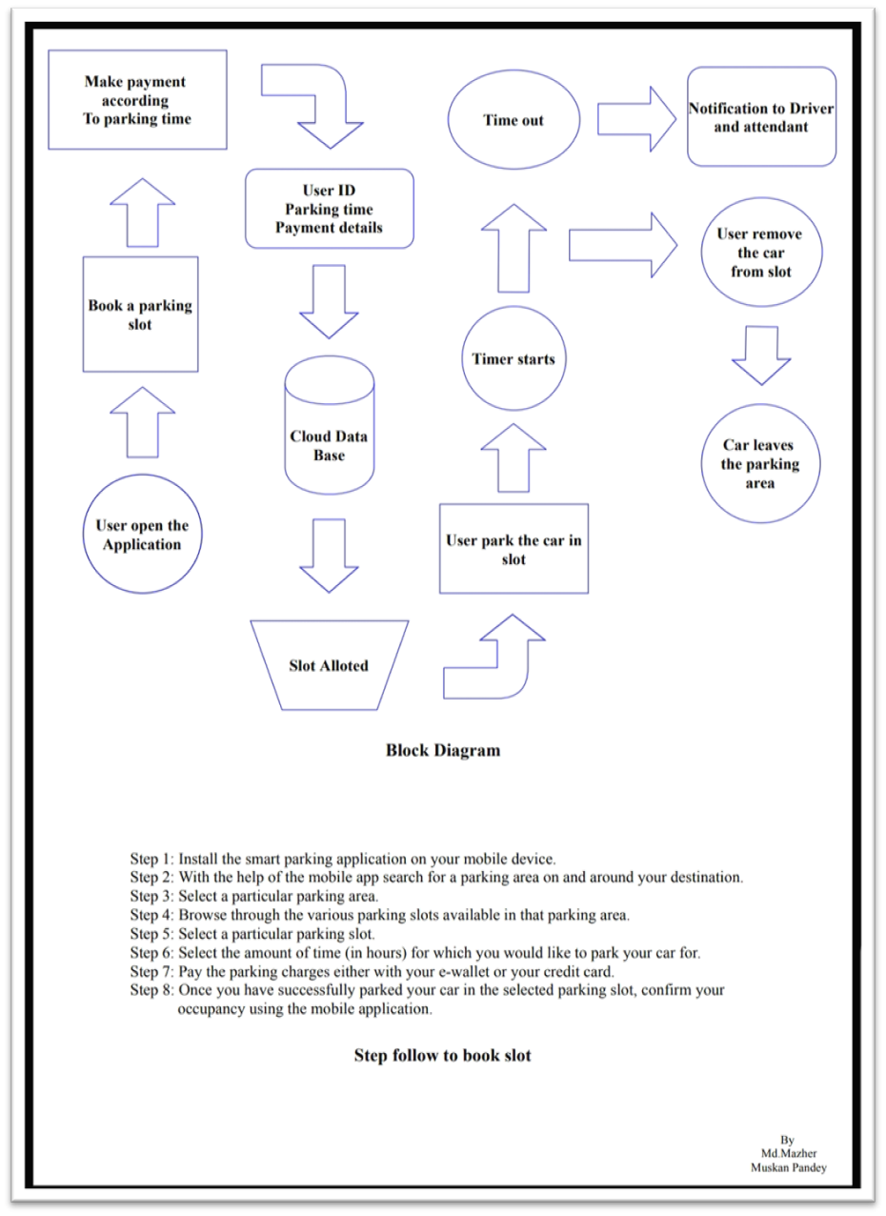

**WORKING**

Hardware - Here we have used Raspberry Pi4 as our main controller board. All the IR Sensor is connected to the board. These Sensor will be placed bottom surface of every slot to detect the presence of vehicle. When they detect object, this sensor generate logic 0 or 0v else the output is generally logic 1 or 2+ volt. Then, this data is fed live to the google firebase systems, Which contain **SLOTA**. we can implement n number of slot, depend upon our requirement.

SLOTA – represent sensor 1 output.

When no object is detected, for example **SLOTA : 0** (This show that Slot is empty, can be book). When object is detected, for example **SLOTA : 1** (This show that Slot is occupy, cannot book).

Note – We can add n number of sensor, depending upon our requirement.

Application - Here we have used Kodular platform to develop an android app, this app consist of authentication and booking screen. Authentication - Signup, login.

Signup Screen - Thisis the main screen, where user need to fill all the details like name, password etc. This signup system is one-time signup system (one device one ID). Since every smart phone have unique ID. When signup button is click, Unique ID (device ID) a bucket is create over firebase which will be used later for authentication and all the booking details will be save over there.

Login Screen - Where user name and password is cross checked with the database, to ensure that whether user have account or not. Once it approved, then only user can jump to the booking screen.

Booking Screen - It consist of SLOTA( show status of IR Sensor).By clicking on click for Availability button. For example SLOTA will Show Available (when **SLOTA : 0**) and Not available (when **SLOTA : 1**). A field is provided for Selecting slot, date, time, vehicle type and number. All this detail will be upload in the firebase under the Device ID bucket, When user click submit button and a countdown will begin. This countdown is based on time you selected above. User cannot park the vehicle more than 60 minutes. When user countdown is completed. A book again button is shown up for booking again, other than this we have cancel as well as exit button to cancel booking or leave the application.

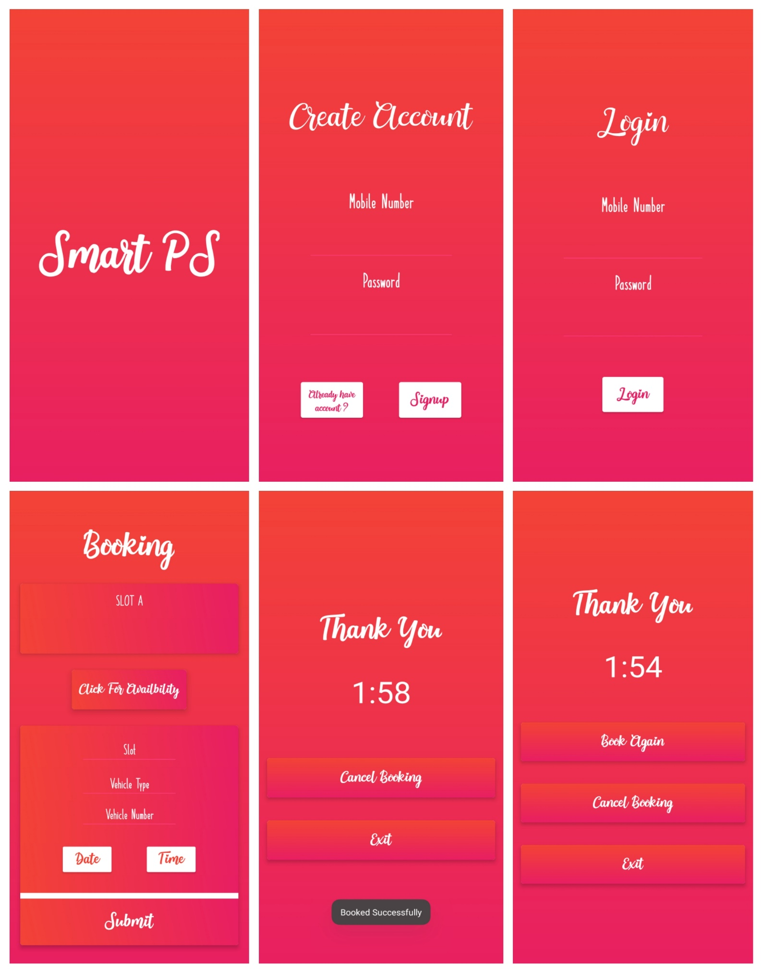 **SAMPLES**

Google Firebase Console look like this, Once you completed registration and booking.

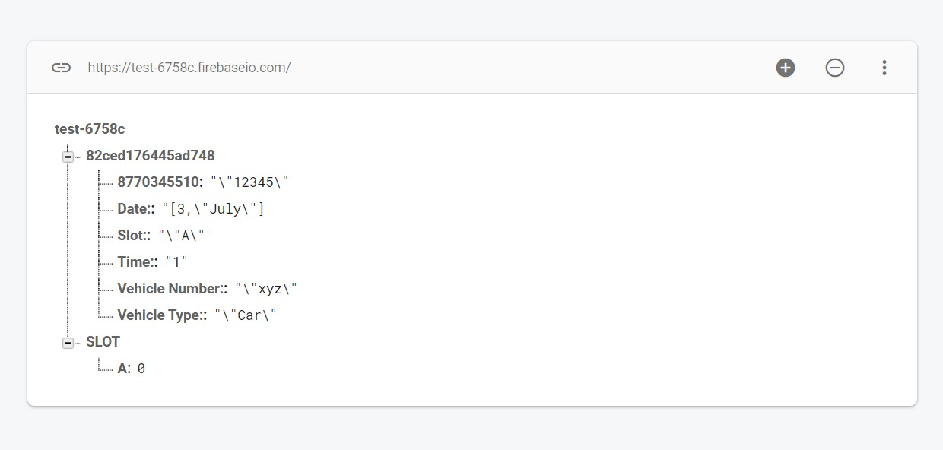

**CODE**

**import RPi.GPIO as GPIO**

**import time**

**from firebase import firebase**

**GPIO.setmode(GPIO.BCM)**

**GPIO.setwarnings(False)**

**GPIO.setup(20, GPIO.IN) #IR SENSOR.**

**url = 'https://test-6758c.firebaseio.com/'**

**firebase = firebase.FirebaseApplication(url)**

**while True:**

**j=GPIO.input(20) #THE OUTPUT OF IR SENSOR STORING IN J VARIABLE.**

**if(j==True):**

**firebase.put("SLOT","A",0) #if IR Sensor Detect Nothing, OUTPUT WILL BE 0.**

**if(j==False):**

**firebase.put("SLOT","A",1) #if IR Sensor DetectVEHICLE, OUTPUT WILL BE 1.**

**CIRCUIT LAYOUT**

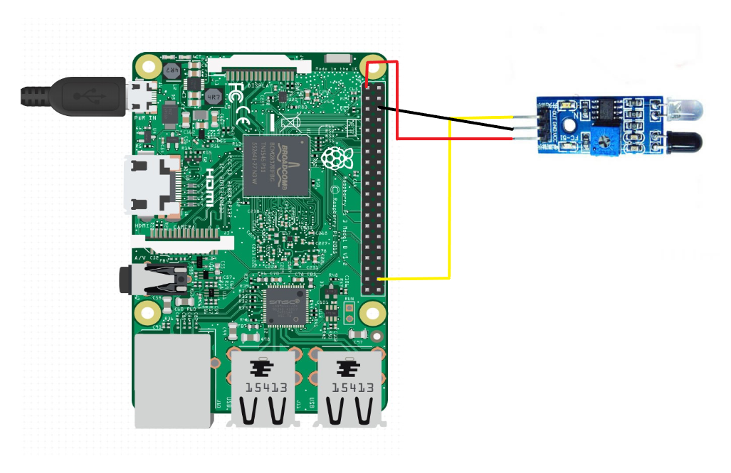

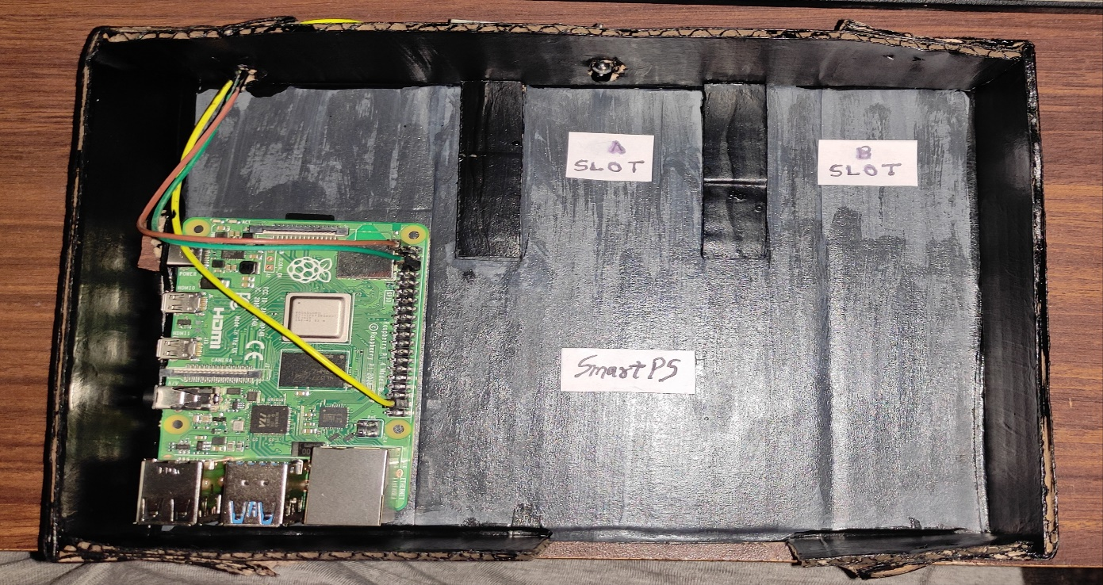

Here we have used GPIO 20 as input pin, sensor Output is connected here. sensor Ground and Vcc is connected to Ground and Vcc of RaspberryPi4

**FUTURE SCOPE**

* Many events like IPL matches etc. Where mass gatherings takes place can be managed efficiently by using this system in parking lot.
* This can be used in MNC's parking area for saving time due to improper traffic issues.
* This can also be used in institute's parking for manageable parking of buses and vehicles.

**CONCLUSION**

Thiswill minimize the problem of parking at the same time save fuel, money, time and save us from co2 emission as well. For maintenance of system some people will be there, hence it will generate job opportunity.

**REFERENCE**

* <https://www.mapsofindia.com/my-india/government/parking-problems-in-india>

Note – Some feature is not included in the Application, As Application is still under development.

Feature Like

* Live location
* Payment system